Q. Create a dataset of a single variable comprising of only numerical values. Create a Normal distribution for it. Convert it to Z distribution and plot both of the distribution.

Code:

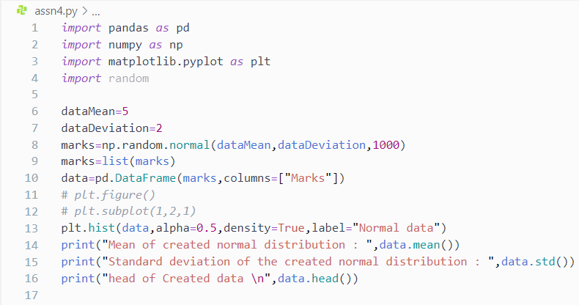

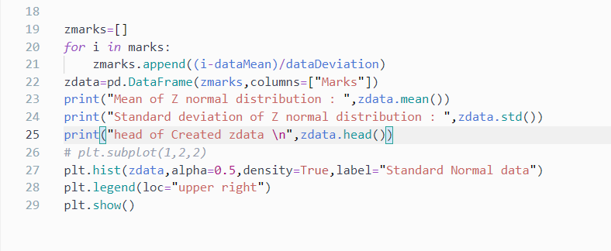

Output:

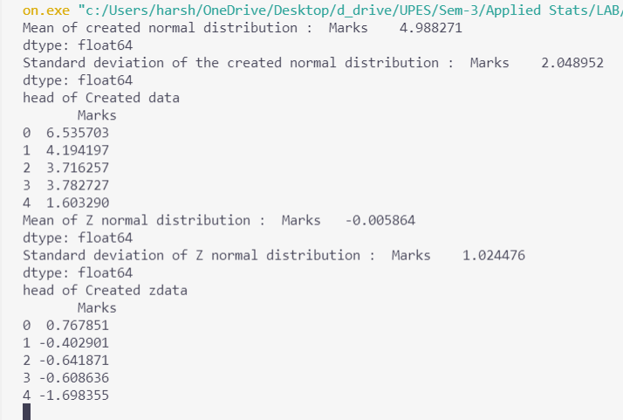

Plot:

